Appendix B: Procedural Workflows for Collaborative Provision

B1 Academic Misconduct Workflow
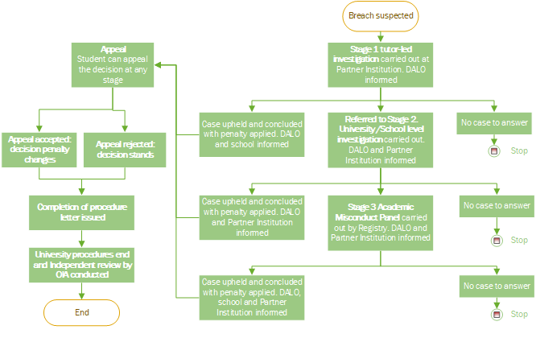

B2 Student Complaints Workflow
B3 Results Appeals Workflow
B4 Fitness to Practise Workflow
B5 Support to Study Workflow
B6 Exceptional Circumstances Workflow
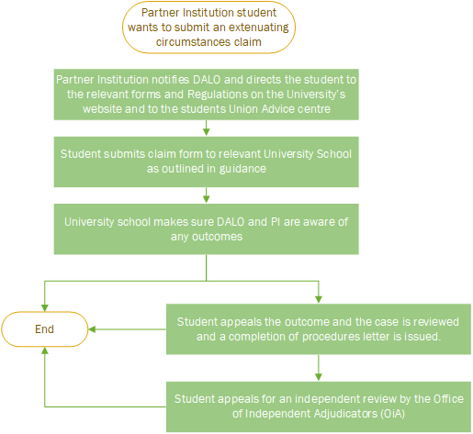
B7 Student Disciplinary Workflow
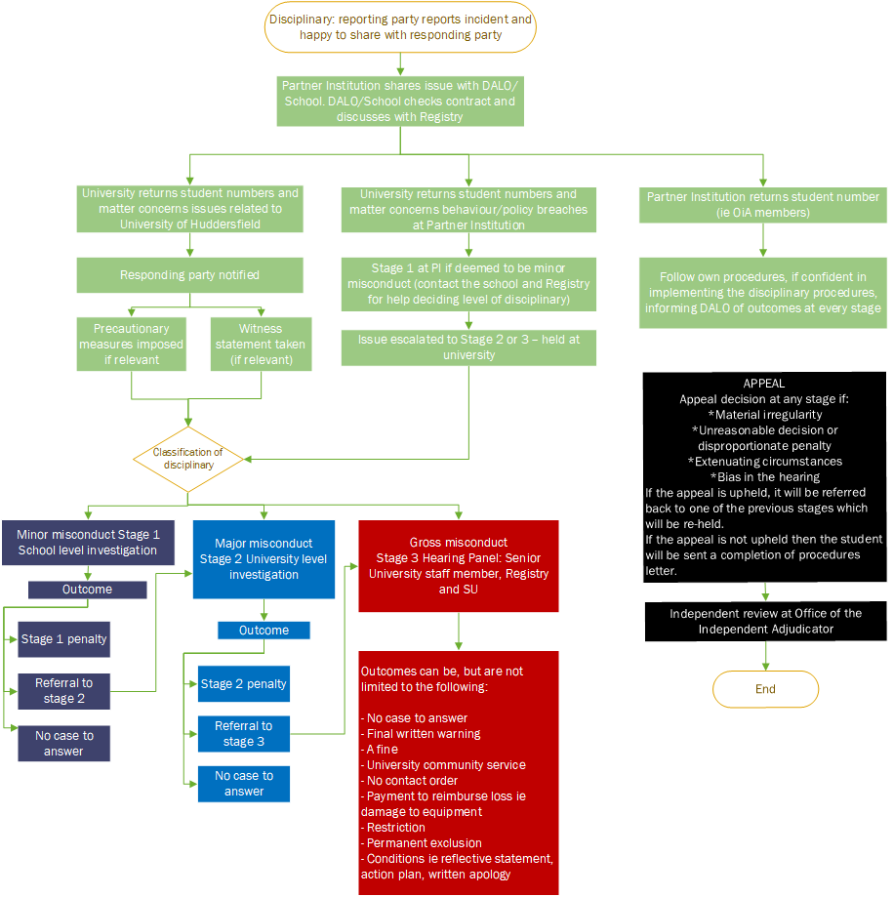
Document Sign-off, Ownership Details and Revision History

