Guide to Using LMI for Subject Review
Why is Labour Market Information (LMI) important?
To achieve the University’s commitment to ‘inspiring global professionals’ courses need to be informed by a good understanding of the world of work that our students will enter when they graduate. Reliable LMI provides an objective basis for this. Knowing the typical graduate outcomes enables course teams to consider how the curriculum develops the right knowledge, skills and experiences. Seeing how their course is relevant to life after university helps motivate students and gives them the confidence they can succeed. LMI therefore forms a vital part of Course Validation, Annual Evaluation and Subject Review.

Introduction
This process is to be used to update course documentation to ensure that PSDs align with requirements and good practice that came into effect from Aug 2022.
Renewing documentation is a valuable opportunity to reflect on current practice, and in the context of the 5 yearly cycle identify long term enhancements.
New courses are required to use labour market information for:
- Marketing Statement
- Course Rationale
- Course Validation.
By working through the steps required for new courses, you will be able to update the documentation for existing courses.
In updating your documentation, you will also need to address other employability aspects of course validation, in particular:
- Mapping the occurrence of the Huddersfield Graduate Attributes (using the MSD and PSD grids).
- Completing the PDP part of the PSD (Appendix 4).
This Guide provides advice and guidance on how update the employability aspects of your documentation.
The Appendix uses a fictional proposed degree in English as a worked example showing how labour market information can be found and used.

The Subject Review Process
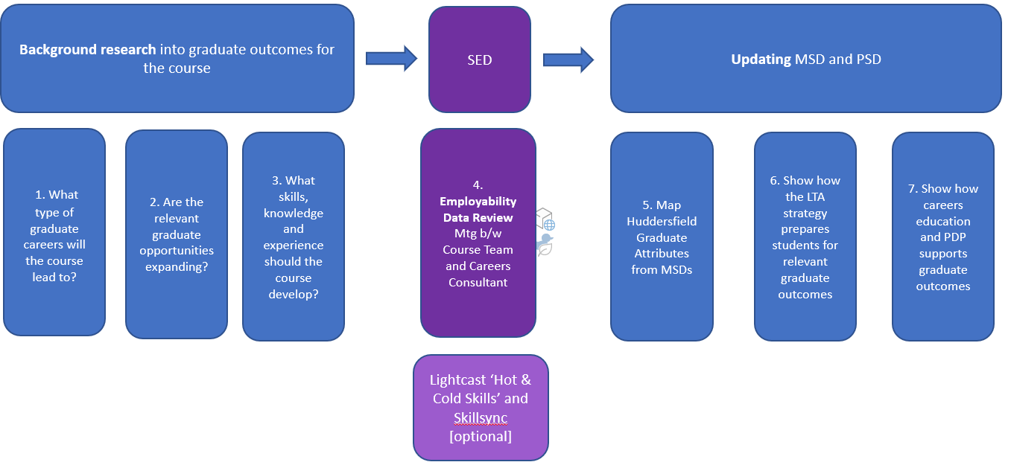
The Employability Data Review meeting is a crucial part of the Subject Review. It is an opportunity to reflect on what has changed in the world of work over the last 5 years. Course Teams may wish to request additional Lightcast reports from their School’s Designated User to illuminate key issues. For example:
- Hot and Cold Skills shows how the skills sought by employers for a particular occupation have changed between two points in time.
- Skillsynch shows which work-related skills are explicitly mentioned in course descriptions and the occupations that correspond to these.

You will need to know | Information you can use | How these help / how to use them
- What types of graduate careers would this course lead to? Identify around 10 that are representative of likely outcomes. Use one of more of the following as required: | While there are many sources of information, in practice you may need to use only two or three to get a good idea of the likely graduate outcomes. | Consider how to save the analysis you do so the data can be used in the future by your course team to inform employability work, and so that you have it accessible if you need to refer back to it as part of your evidence base through the Subject Review processes.
 | What Do Graduates Do?  https://luminate.prospects.ac.uk/what-do-graduates-do | This shows the top 10 graduate occupations for broad disciplines like History, Biology, Business and Managements studies, using the latest national data.
 | What Can I Do with My Degree?  https://www.prospects.ac.uk/careers-advice/what-can-i-do-with-my-degree | This lists jobs ‘directly related to your degree’ and jobs ‘where your degree would be useful…’ for around 99 degree disciplines, drawing on national data and research by careers professionals.
 | Graduate Outcomes data from the University of Huddersfield as shown in Apollo.  Apollo Dashboard (hud.ac.uk)  Tiled Dashboard | Use the Tiled Graduate Outcomes report to see the top 5 Occupations for a course on the upper right-hand side tab. Important: to see the graduate level occupations you need to use the ‘Highly skilled worker marker’ filter from the left-hand tool bar, and tick ‘Highly skilled’. The default setting shows outcomes data from University of Huddersfield home undergraduates. [For a more granular look at GO data for UoH – please ask your Careers Consultant)].
 | Lightcast Report (using JACS Codes) | Lightcast is a proprietary LMI dashboard that the University has a licence for which can be used to identify degree related occupations using HECoS (the classification systems that has replaced JACS code). Please ask your School’s Designated User about this if you would like a report.
 | Options with My Degree (from University of Huddersfield Careers and Employability Service).  Employability Resources SharePoint site:  https://hudac.sharepoint.com/sites/U92-INT-EmployabilityResources | Drawing on national and local data these word docs provide a realistic picture of likely outcomes for our students covering around 40 discipline areas. [NB. There are bite sized video versions you can share with your students. Ask your Careers Consultant for more information.]
- Do you have any evidence that relevant graduate occupations are expanding? Provide a single Lightcast Occupational Comparison Report for the graduate careers which are most important for this course (this might be for all the typical outcomes or a key sub-set). | Find who the Lightcast Designated User is for your School by checking the list in the Lightcast Folder.  Employability Resources SharePoint site:  https://hudac.sharepoint.com/sites/U92-INT-EmployabilityResources | Lightcast is a proprietary LMI dashboard the University has a licence for.  Your School’s Designated User will create a report for you which should be attached to the Marketing Statement.  A single Occupational Comparison report can cover multiple occupations. The report uses UK Government economic data to show occupational change . Your report should cover the graduate outcomes identified above for your course that the course team regards as most important. This may be for all the identified graduate occupations or a sub-set. The report should show data for the Leeds, Manchester and Sheffield LEP areas, unless your course has a markedly different demographic. To provide a balanced perspective the report should cover the preceding 5 years and the following 5 years (so 11 years in all). The forward-looking data gives a ‘trend-based projection’ and not a prediction. When looking at the data it should be born in mind that it shows changes for broad occupations, which will include but not be limited to graduate starting roles. If this report suggests a significant reduction in opportunities, as an optional step, you may wish to provide an Occupational Table which shows the number of openings per year. Again, you can request this from your Designated User.
- To prepare students for relevant graduate outcomes (including, where applicable, self-employment), what specialised and common skills, knowledge and experiences should the course develop? | Provide a separate Lightcast Jobs Postings Analytics Report for each of the relevant graduate occupations identified, to show the specialised and common skills needed.  - Optional: you may also attach skills information taken from Prospects Jobs Profiles (if Lightcast not sufficient / appropriate). | Lightcast is a proprietary LMI dashboard the University has a licence for.  Your School’s Designated User will create these reports for you which should be attached to the Course Rationale documentation.  These reports will draw on big data taken from recent jobs posted by employers. Each report will show the top specialised skills (generally technical skills) and the top common skills, as specified in employers job adverts.  It is ideal if each report shows the top 20 specialised skills for each occupation (to provide a nuanced list) as well as the top 20 common skills. You may wish to provide these reports in their entirety (as pdfs) or simply screen grabs of key sections.

To update the PSD you are asked | You should refer to | Information you can use | How these help / how to use them
- … demonstrate how the LTA strategy prepares students for relevant graduate outcomes. This section of the PSD should: identify the main occupations which are representative of the typical graduate outcomes for the course and identify the specialised and common skills needed for these by attaching the reports used for the Marketing Statement; address the ways in which the LTA strategy (including reference to specific modules, or assessments) prepares students for these graduate careers (including, where applicable, self-employment,) with the skills, knowledge and experiences required | What types of graduate careers would this course lead to? Identify around 10 that are representative of likely outcomes. Use one of more of the following as required: | For Subject Review, refer to the sources above. | For Subject Review, refer to the analysis above.
 | Do you have any evidence that relevant graduate occupations are expanding? Provide a single Lightcast Occupational Comparison Report for the graduate careers which are most important for this course (this might be for all the typical outcomes or a key sub-set). | For Subject Review, refer to the sources above. | For Subject Review, refer to the analysis above.
 | To prepare students for relevant graduate outcomes (including, where applicable, self-employment), what specialised and common skills, knowledge and experiences should the course develop? | For Subject Review, refer to the sources above. | For Subject Review, refer to the analysis above
The Employability & Enterprise Resources SharePoint site has specialised reports in the Labour Market Information folder which you can draw on as appropriate.
https://hudac.sharepoint.com/sites/U92-INT-EmployabilityResources
The Future World of Work Global Trends pdf has links to advice on how to address employability through the subject curriculum (pages 43-46) which are relevent to this part of the PSD.
- …using Appendix 4, show how careers education supports this and contributes to the PDP requirement…. | In Appendix 4 you are guided through a simple process to: (a) identify things you have planned in your course that contribute to Personal Development Planning - PDP; (b) consider the employability context for your course; (c) say what sort of careers inputs are needed to support your students. | Appendix 4 identifies a range of resources to use.  The data gathering undertaken for the analysis above will provide most, if not all, of the background analysis needed for Appendix 4.

Appendix: A Worked Example for a Fictional Proposed English UG Degree
Please note the worked example illustrates possible ways of using the resources and is NOT a guide to the outcomes for the sample degree shown.
Question One: What types of graduate careers would this course lead to?

Use Prospects What Do Graduates Do? To identify the top 10 graduate Outcomes  https://graduatemarkettrends.cdn.prismic.io/graduatemarkettrends/8d0f5a43-fe6e-4b78-b710-4c22baa1db5e_what-do-graduates-do-2021-22.pdf | Prospects https://www.prospects.ac.uk/careers-advice/what-can-i-do-with-my-degree)
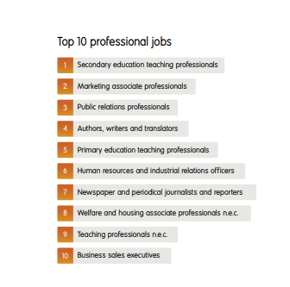 | 
You could also look at Apollo for actual Graduate Outcomes from the University of Huddersfield. [NB. If you are doing this for a new course proposal, there may still be a similar course we have run which could provide relevant data, if carefully suitable interpreted] and Lightcast for national LMI derived data.
Apollo (NB. The search below covers English Studies, English Language and Linguistics etc.) | Lightcast (Jobs Posting report for English Studies JACS Q300). NB. The query identifies a range of occupations using the transferable skills from the degree and uses longitudinal data to identify occupations associated with holders of the degree. The initial long list must be narrowed to select the most likely occupations for new / recent graduates).
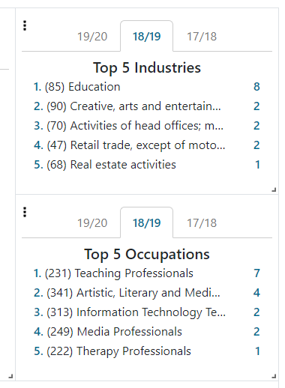 | 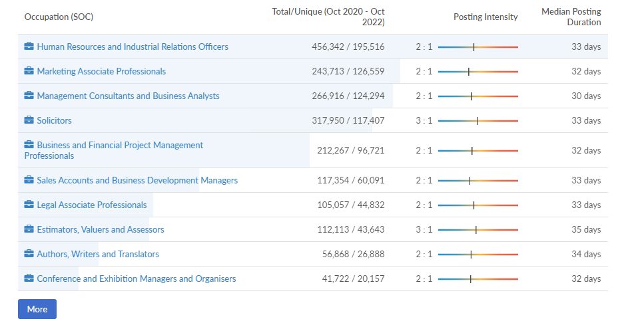

Drawing on national and local data these word docs provide a hand-picked picture of likely outcomes for our students covering around 40 discipline areas. [NB. There are bite sized video versions you can share with your students. Ask your Careers Consultant for more information.]
Options With My Degree | Options With My Degree
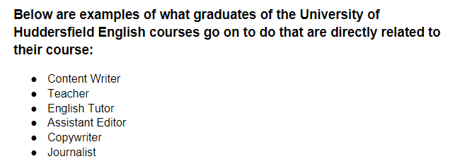 | 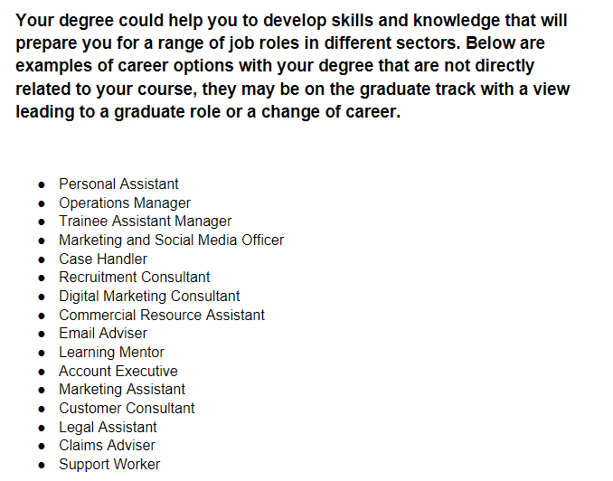
Next, drawing upon the various sources you have used, the course team decides which graduate occupations are most representative and useful for curriculum planning.
We would suggest around 10 occupations are selected to provide a manageable number as well as a representative spread. For some courses with a very specific vocation or professional focus the number may be smaller and restricted to occupations within the same sector or profession. NB the following selection is therefore purely illustrative.
Occupations selected (illustrative example). | Standard Occupational Classification Codes (SOC) are used by the UK Government to classify occupations by level. (while you do NOT need to state these, they have been provided for reference). SOC codes for Graduate Level / Highly Skilled occupations are ONLY those which start with a 1, 2 or 3. Please remember that Lightcast uses SOC 2010 version (as per historic ONS data sets). However, HESA and our Graduate Outcomes reports uses the newer SOC 2020 version.
Secondary Education Teaching | 2314
Marketing Associate Professionals | 3543
Public Relations Professionals | 2472
Authors, Writers and Translators | 3412
Primary Education Teaching Professionals | 2315
Human Resources and Industrial Relations Professionals | 3562
Newspaper and periodical journalist and reporters | 2471

By identifying the occupations representative of the degree outcomes the challenges and opportunities can be deliberately addressed in the course, through choice of topics, case studies, authentic assessment, live projects, placement opportunities and skills development etc. Having a specific set of careers to target helps to position students for these careers through ‘constructive alignment’ and at the same time develops transferable skills which can be applied to other more diverse degree relevant careers.

Question Two: Do you have any evidence that relevant graduate opportunities are expanding?

Your Lightcast Designated User will undertake the following search for you and provide you with the Occupational Comparison report. If you are creating this when proposing a new course, the Report should be sent to Marketing and attached to your to Marketing Statement. Remember that you will only need one Occupational Comparison report as the report can compare multiple occupations.
Please note regarding Lightcast, it is only Occupational reports that should be sent to Marketing. Please do NOT send Jobs Posting reports to Marketing.

Step 1: Meet your School’s Lightcast Designated User (DU) and discuss the selection of typical graduate outcomes you have chosen.

Step 2: DU Find the occupations by entering them into the search bar (shown below).
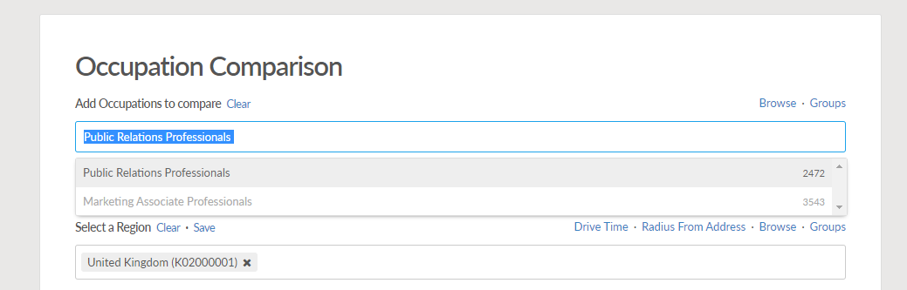

If a direct match is not available, use the Online CASCOT tool to find the best occupational match (and SOC code) and then create the and create a search. (NB if pasting text into the search bar Lightcast may not find any results if the text match is not an exact match. If this happens, try typing the start of the text descriptor instead). https://cascotweb.warwick.ac.uk/#/classification/soc2010 (NB currently Lightcast uses SOC 2010 version).

Step 3: Set the Region to the Leeds, Manchester and Sheffield LEP areas.

Step 4: Set the Timeframe to 5 years in the past and 5 years in the future.
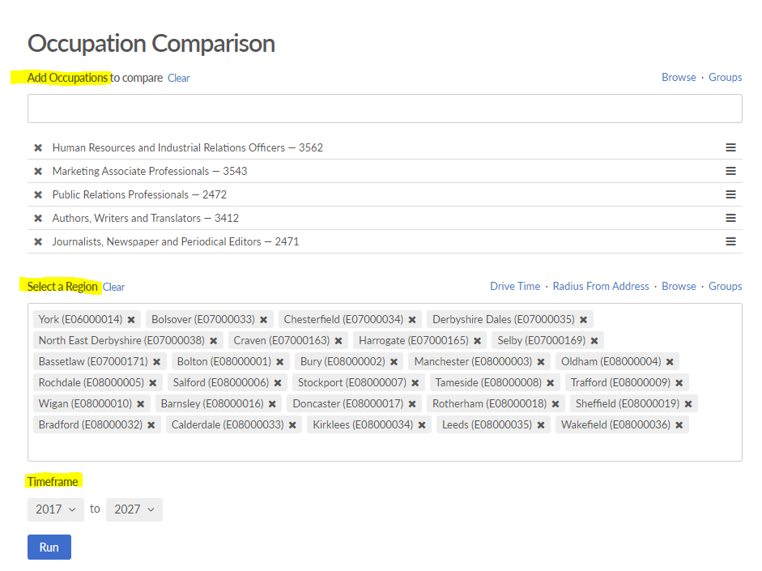
Step 5: Run the report, save in Lightcast and share as a pdf with the course team.
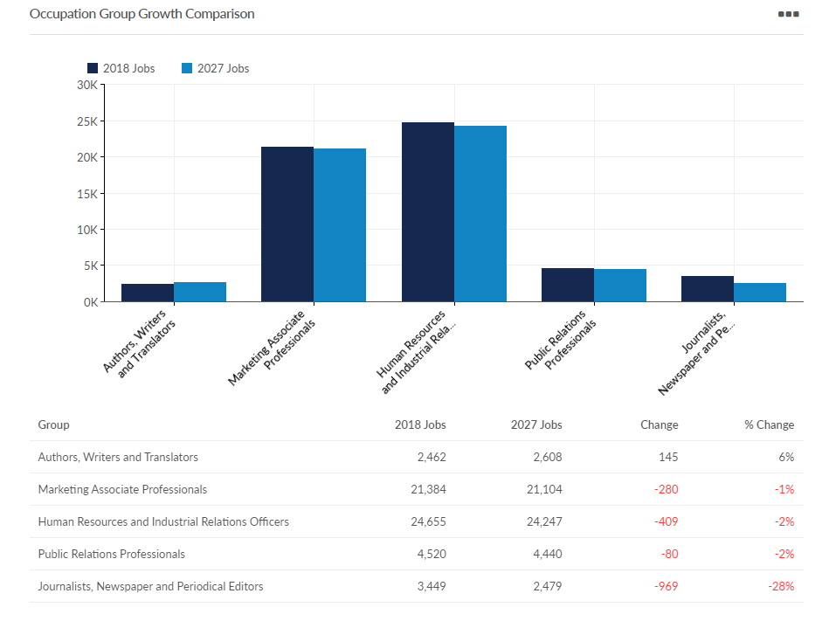

When viewing the results please bearing mind that:
- The historical occupational data is drawn from official UK government data sources and while no data is without potential issues this is the most reliable, objective and comprehensive data set possible.
- The results are for ‘occupational areas’ covering a range of occupations, including, but not limited to (new) graduate roles.
- Future data should be regarded as ‘trend-based projections’ rather than predictions.

You can use this data to answer questions like:
- What is the size of the different occupational areas compared to each other?
- Are there big differences in the number of opportunities in the region for the different occupations?
- Are there any outliers?
- Which is largest and which is smallest?
- Have any markedly expanded or declined recently?
- Are any projected to markedly expanded or declined in the near future?

Step 6: Optional Occupational Table Report

If the proposed course is heavily dependent upon a limited number of specialised occupations, and the Occupational Comparison Report indicates a possible (and significant) reduction in opportunities, then it is recommended that an Occupational Table Report is also produced for the occupations concerned to show in more detail the normal and projected number of openings (new jobs and vacancies created by ‘churn’). Please note that this is an optional element.

Question Three: To prepare students for relevant graduate outcomes (including, where applicable, self-employment), what specialised and common skills, knowledge and experiences should the course develop?

Step 7: Create Jobs Postings Analytics Reports
Your Lightcast Designated User will undertake the following searches for you and provide you with the Jobs Posting Analytics reports. To show the distinctive mix of skills needed, a separate report will be needed for each of the occupations identified by the course team as being especially important.

Step 8: Set the region to Leeds, Manchester and Sheffield LEP areas, unless your course as a different demographic.
Step 9: Set the time frame to the last 12 months to ensure that results reflect the current labour market.
Step 10: Run the report, save in Lightcast and share as a pdf with the course team.
Example snip from Jobs Postings Analytics Report: Journalist, Newspapers and Periodical Editors.
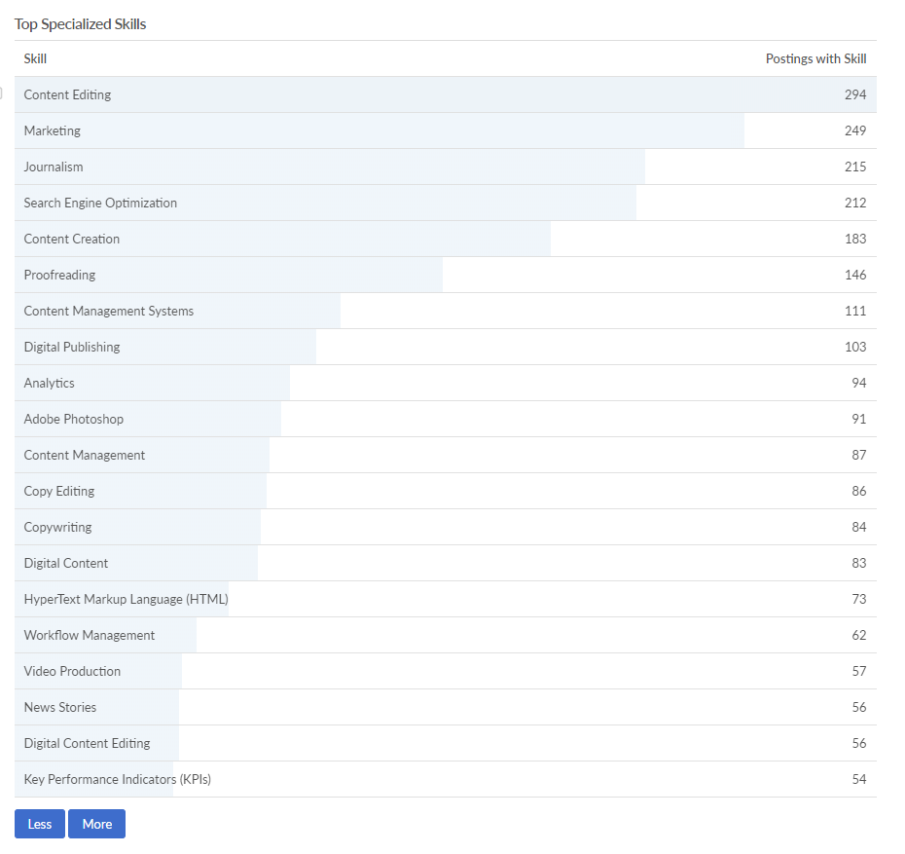 | 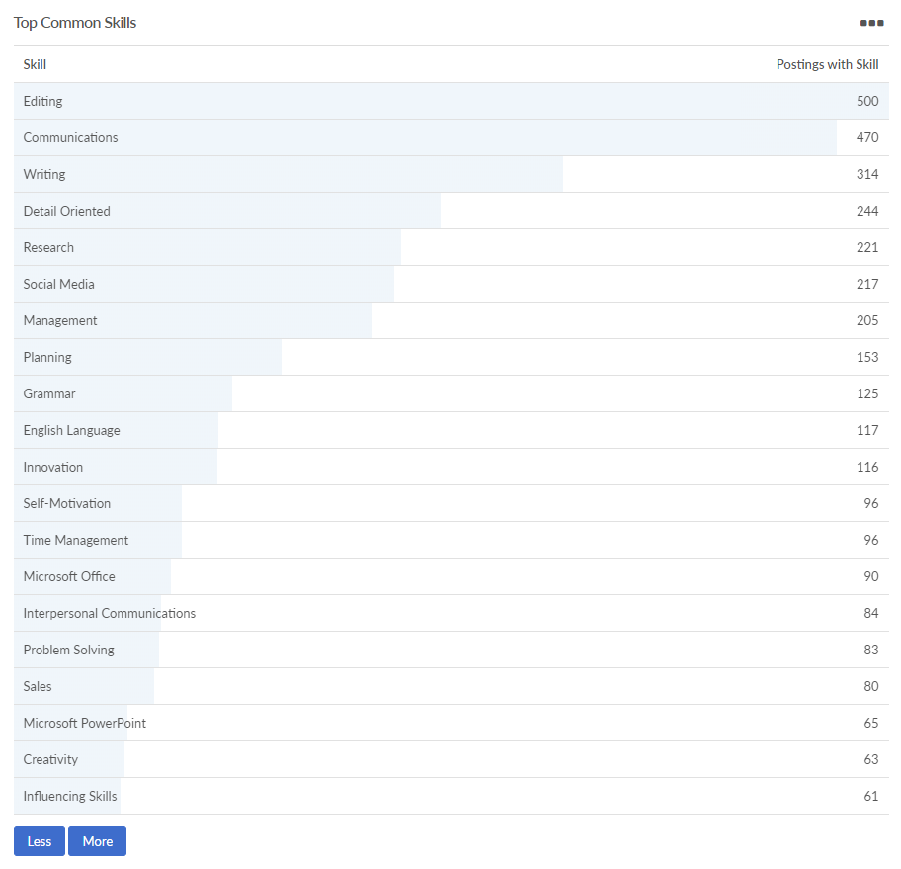
Doc created: 08/12/2022

